ULTIMA 2.0
CS-435 Operating System
Phase 5—Implementation and Presentation

By:

Drake Wood
drawood@iu.edu

James Giegerich
jgiegeri@iu.edu

4/29/19

Table of Contents
Phase Abstract 2
Phase Description 3
Design Diagram 4
Source Code 5
Main.cpp 5
Semaphore.h 8
Semaphore.cpp 10
Window.h 12
Window.cpp 13
Queue.h 22
Queue.cpp 25
Scheduler.h 27
Scheduler.cpp 29
ipc.h 34
ipc.cpp 36
Memory.h 42
Memory.cpp 44
UFS.h…………………………………………………………………………………………………………………………………………………………………………….……52
UFS.cpp………………………………………………………………………………………………………………………………………………………………………………55
Makefile 62
Output 63

Phase Abstract
This report details the design and development of the fourth phase of the Ultima 2.0 project for C435. This program is written in C++ and is designed to run on a Unix operating system. This program and design are meant to be added to and upgraded in future iterations to add more features. This report includes the full source code as well as design diagrams.

Phase Description

This phase is to test our implementation of the various concepts discussed throughout the semester. To do this, we developed several test cases to show certain components working properly. We use a sequence of testing function calls to show how they work or could be improved. These are kept in our UI loop switch case. Upon developing worker functions to test the integration of our entire system, we ran into several issues that we were not able to solve. Most of our worker functions brought screen corruption and segmentation faults, so there is little to show for the implementation for those.

Design Diagram
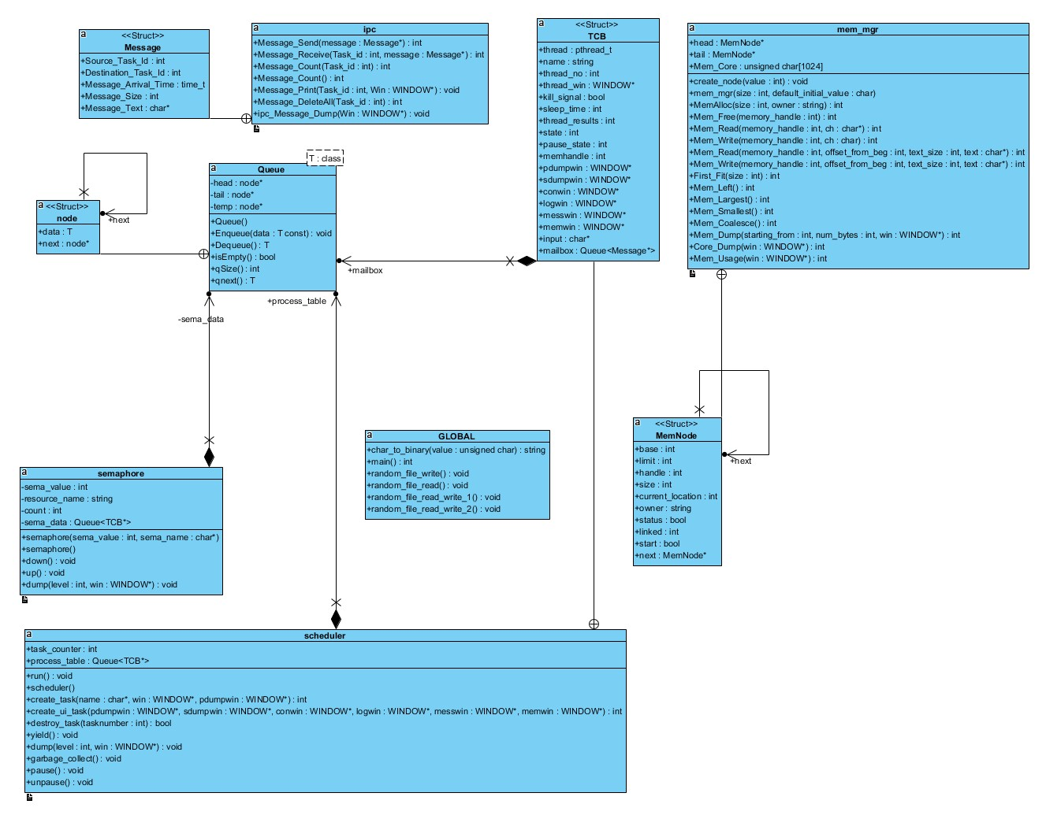

Source Code

Main.cpp
/*==================================================================================|
| Assignment: Ultima 2.0 Phase 4
| File Name: main.cpp
| Dependencies: scheduler.h semaphore.h window.h queue.h
| Authors: Drake Wood, James Giegerich
| Language: C++
| Compiler: G++
| Class: C435 - Operating Systems
| Instructor: Dr. Hakimzadeh
| Date Created: 2/16/2019
| Last Updated: 4/08/2019
| Due Date: 4/08/2019
|==================================================================================|
| Description: Contains the main function that interacts with the scheduler, semaphore, queue, and window classes.
| Multiple curses windows and 3 pthreads are created which are then passed to other functions to handle.
| The rest of main contains an input loop for the user to control what happens while the program is running.
| Details of the way functions are used and their parameters as well as
| computation details are given in the class descriptions.
*==================================================================================*/

#include <iostream>
#include <pthread.h> // Needed for using the pthread library
#include <assert.h>
#include <time.h>
#include <unistd.h> // Needed for sleep()
#include <ncurses.h> // Needed for Curses windowing
#include <stdarg.h> // Needed for formatted output to window
#include <termios.h>
#include <fcntl.h>
#include <cstdlib>
#include "queue.h"
#include "scheduler.h"
#include "semaphore.h"
#include "window.h"
#include "memory.h"
#include "ufs.h"

using namespace std;

semaphore sema_deadlock(1, (char*)"Deadlock Test");
semaphore sema_screen(1, (char *)"Screen Print"); // creates semaphores
semaphore sema_t1mail(1, (char *)"t1mail");
semaphore sema_t2mail(1, (char *)"t2mail");
semaphore sema_t3mail(1, (char *)"t3mail");
semaphore sema_t4mail(1, (char *)"t4mail");
semaphore sema_ptable(1, (char *)"ptable");
semaphore sema_memory(1, (char *)"memory");
semaphore sema_filef(1, (char *)"Filesystem");
semaphore sema_inodef(1, (char*)"iNode");
scheduler sched; //creates scheduler
ipc IPC; // creates ipc
mem_mgr Mem_Mgr(1,1); // creates mem manager - size, initial value - dont do anything right now
ufs superuser("superuser", 16, 128, '^'); // creates file system for the super user
//16 blocks, 128 byte block size, ^ initialization character
//------------------------------------------------------------------------------
//------------------------------MAIN--------------------------------------------
//------------------------------------------------------------------------------

int main() {
initscr(); // Start nCurses
refresh(); // Refresh screen

//------------------------------------------------------------------------------
//Creating heading window, printing content
//------------------------------------------------------------------------------

WINDOW * Heading_Win = newwin(5, 80, 0, 2);
box(Heading_Win, 0,0);
mvwprintw(Heading_Win, 1, 26, "ULTIMA 2.0 Phase 3 (Spring 2019)");
mvwprintw(Heading_Win, 3, 28, "Drake Wood James Giegerich");
wrefresh(Heading_Win);

//------------------------------------------------------------------------------
//Creating log window
//------------------------------------------------------------------------------

WINDOW * Log_Win = create_window(15, 60, 20, 2);
write_window(Log_Win, 1, 18, "...........Log...........\n");

//------------------------------------------------------------------------------
//Creating console window
//------------------------------------------------------------------------------

WINDOW * Console_Win = create_window(15, 20, 20, 62);
write_window(Console_Win, 1, 1, " ....Console....\n");
write_window(Console_Win, 2, 1, "Ultima # ");
write_window(Log_Win, " Main program started\n" );

//------------------------------------------------------------------------------
//Creating 3 windows for tasks
//------------------------------------------------------------------------------

WINDOW * W1 = create_window(15, 25, 5, 2);
WINDOW * W2 = create_window(15, 25, 5, 30);
WINDOW * W3 = create_window(15, 25, 5, 57);

//------------------------------------------------------------------------------
//Creating a process table dump window
//------------------------------------------------------------------------------

WINDOW * Process_Table = create_window(9, 80, 0, 83);
write_window(Process_Table, 1, 5, " PROCESS TABLE DUMP \n -------------------------------------\n");

//-------------------------------------------------------------------------------
//Creating a semaphore dump window
//-------------------------------------------------------------------------------

WINDOW * Sema_Dump = create_window(16, 80, 9, 83);
write_window(Sema_Dump, 1, 5, " SEMAPHORE DUMP \n -------------------------------------\n");

//------------------------------------------------------------------------------
//Creating tasks with create_task passing each a name and task window
//------------------------------------------------------------------------------

sched.create_task((char*)" Task 1", W1,Process_Table, Sema_Dump);
sched.create_task((char*)" Task 2", W2,Process_Table, Sema_Dump);
sched.create_task((char*)" Task 3", W3,Process_Table, Sema_Dump);

//-------------------------------------------------------------------------------
//Creating a memory dump window
//-------------------------------------------------------------------------------

WINDOW * Mem_Dump = create_window(22, 80, 35, 2);
write_window(Mem_Dump, 1, 5, " MEMORY DUMP \n --------------------------------------------------------\n");

//------------------------------------------------------------------------------
//Create a Messaging dump window
//------------------------------------------------------------------------------

WINDOW * Message_Dump = create_window(17, 80, 25, 83);
write_window(Message_Dump, 1, 5, " MESSAGING DUMP \n -------------------------------------\n");

//------------------------------------------------------------------------------
//Setup for user console input
//------------------------------------------------------------------------------

cbreak(); // Set up keyboard I/O processing
noecho(); // disable line buffering
nodelay(Console_Win, true); // disable automatic echo of characters read by getch(), wgetch()
// nodelay causes getch to be a non-blocking call.
// If no input is ready, getch returns ERR

//------------------------------------------------------------------------------
//Start threads and run till end of program
//------------------------------------------------------------------------------

sched.run(); //start running all the tasks

sched.create_ui_task(Process_Table, Sema_Dump, Console_Win, Log_Win, Message_Dump, Mem_Dump);

while(sched.process_table.qSize() != 0){ // loop while threads run
sleep(1);
}

endwin();
return 0;
} // end of main

Semaphore.h
/*==================================================================================|
| Assignment: Ultima 2.0 Phase 3
| File Name: semaphore.h
| Dependencies: scheduler.h
| Authors: Drake Wood, James Giegerich
| Language: C++
| Compiler: G++
| Class: C435 - Operating Systems
| Instructor: Dr. Hakimzadeh
| Date Created: 2/16/2019
| Last Updated: 3/18/2019
| Due Date: 4/08/2019
|==================================================================================|
| Description: This is the header file which defines the class semaphore. There are 3 functions along with a
| constructor and deconstructor.
| -dump displays information related to this class in a window for debugging.
| -up creates a mutex and queues it, effectively locking a critical section.
| -down dequeues a mutex, unlocking it.
*==================================================================================*/

#ifndef SEMAPHORE_H
#define SEMAPHORE_H

#include <iostream>
#include <pthread.h> // Needed for using the pthread library
#include <assert.h>
#include <time.h>
#include <unistd.h> // Needed for sleep()
#include <ncurses.h> // Needed for Curses windowing
#include <stdarg.h> // Needed for formatted output to window
#include <termios.h>
#include <fcntl.h>
#include <cstdlib>
#include "queue.h"
#include "scheduler.h"
#include <string>

class semaphore {
int sema_value; // 0 or 1 in the case of a binary semaphore

Queue <scheduler::TCB*>sema_data;
std::string resource_name; // The name of the resource being managed
int count;

public:
semaphore(int sema_value, char* sema_name);
~semaphore();

void down(); // Get the resource or get queued!
void up(); // Release the resource
void dump(int level, WINDOW * win); // Include some
}; // Functions which will allow you to dump the
#endif // Contents of the semaphore in a readable format. See the expected
// Output section (below) for suggestions.

Semaphore.cpp
/*==================================================================================|
| Assignment: Ultima 2.0 Phase 3
| File Name: semaphore.cpp
| Dependencies: semaphore.h window.h
| Authors: Drake Wood, James Giegerich
| Language: C++
| Compiler: G++
| Class: C435 - Operating Systems
| Instructor: Dr. Hakimzadeh
| Date Created: 2/16/2019
| Last Updated: 4/08/2019
| Due Date: 4/08/2019
|==================================================================================|
| Description: Contains the definitions for the functions outlined in semaphore.h
*==================================================================================*/

#include "window.h"
#include "semaphore.h"
#include "scheduler.h"

extern semaphore sema_screen;
extern scheduler sched;
extern scheduler TCB;

void semaphore::down(){ // Lock resource

scheduler::TCB * tcb; // new tcb object

if (sema_value > 0){ // if no 1 else has access
sema_value--; // get access here
} else{ // if someone else has access then we need to queue and block ourselves
tcb = sched.process_table.Dequeue();
tcb->state = 0; // blocked
sched.process_table.Enqueue(tcb); //add back to process table
sema_data.Enqueue(tcb); // stick in sema queue waitlist

for (int i = 0; i < sched.process_table.qSize() -1 ; i++)
{
tcb = sched.process_table.Dequeue();
sched.process_table.Enqueue(tcb); //shuffle queue
}
}

} // end of down

void semaphore::up(){ // Release the resource

if (sema_data.isEmpty()){ // if no one is in line then set value back to 1
sema_value++;
} else {
scheduler::TCB * tcb = sema_data.Dequeue(); // get first in semaphore queue
scheduler::TCB * tcb2; // new tcb for comparison
for (int i = 0; i < sched.process_table.qSize() ; i++)
{
tcb2 = sched.process_table.Dequeue(); //get scheduler task
if (tcb->thread_no == tcb2->thread_no){ // if task id in scheduler matches the one in semaphore
tcb2->state = 1; //ready // change it to ready from blocked
}
sched.process_table.Enqueue(tcb2); //shuffle queue
}
}
} // end of up

void semaphore::dump(int level, WINDOW * win){
// giving semaphore a resource name

char buff[256];

sprintf(buff, " Resource: %s Sema Value: \t%d \n", resource_name.c_str(), sema_value); // Print the resource name of the current semaphore
write_window(win, buff);

std::string name;
if (sema_data.qSize() > 0){
scheduler::TCB * tcb;

for (int i = 0 ; sema_data.qSize(); i++){
tcb = sema_data.Dequeue();
name = tcb->name;
sema_data.Enqueue(tcb);
sprintf(buff, "%s -> ", name.c_str());
write_window(win, buff);
}
} else{
write_window(win, " \tSema Queue empty\n");
}
} // end of dump

semaphore::semaphore(int sema_value, char* sema_name){
count = 0;
this->sema_value = sema_value;
this->resource_name = sema_name;
}

semaphore::~semaphore(){
}

Window.h
/*==================================================================================|
| Assignment: Ultima 2.0 Phase 3
| File Name: window.h
| Dependencies: none
| Authors: Drake Wood, James Giegerich
| Language: C++
| Compiler: G++
| Class: C435 - Operating Systems
| Instructor: Dr. Hakimzadeh
| Date Created: 2/16/2019
| Last Updated: 3/18/2019
| Due Date: 4/08/2019
|==================================================================================|
| Description: This is the header file which defines the class window. There are 5 functions.
| -create_window draws a new window at a specified size and position, it also turns on scrolling.
| -write_window sends text to a specific window either with a position or without.
| -display_help prints a help window with console options for the user.
| -perform_simple_output is the function that the thread will run while alive, it prints an incrementing message.
*==================================================================================*/

#ifndef WINDOW_H
#define WINDOW_H

#include <iostream>
#include <pthread.h> // Needed for using the pthread library
#include <assert.h>
#include <time.h>
#include <unistd.h> // Needed for sleep()
#include <ncurses.h> // Needed for Curses windowing
#include <stdarg.h> // needed for formatted output to window
#include <termios.h>
#include <fcntl.h>
#include <cstdlib>

WINDOW *create_window(int height, int width, int starty, int startx);
void write_window(WINDOW * Win, const char* text);
void write_window(WINDOW * Win, int x, int y, const char* text);
void display_help(WINDOW * Win);
void *perform_simple_output(void *arguments);
void *ui_loop(void *arguments);

#endif

Window.cpp
/*==================================================================================|
| Assignment: Ultima 2.0 Phase 4
| File Name: window.cpp
| Dependencies: semaphore.h window.h
| Authors: Drake Wood, James Giegerich
| Language: C++
| Compiler: G++
| Class: C435 - Operating Systems
| Instructor: Dr. Hakimzadeh
| Date Created: 2/16/2019
| Last Updated: 4/08/2019
| Due Date: 4/08/2019
|==================================================================================|
| Description: Contains the definitions for the functions outlined in window.h
*==================================================================================*/

#include "window.h"
#include "semaphore.h"
#include "ipc.h"
#include "time.h"
#include "memory.h"
#include <cstring>
#include "ufs.h"

extern semaphore sema_deadlock;
extern semaphore sema_screen;
extern semaphore sema_files;
extern semaphore sema_t1mail;
extern semaphore sema_t2mail;
extern semaphore sema_t3mail;
extern semaphore sema_t4mail;
extern semaphore sema_ptable;
extern scheduler sched;
extern ipc IPC;
extern mem_mgr Mem_Mgr;
extern ufs superuser;

WINDOW *create_window(int height, int width, int starty, int startx)
{
sema_screen.down();
WINDOW *Win;
Win = newwin(height, width, starty, startx);
scrollok(Win, TRUE); // Allow scrolling of the window
scroll(Win); // scroll the window
box(Win, 0 , 0); // 0, 0 gives default characters for the vertical and horizontal lines
wrefresh(Win); // draw the window
sema_screen.up();

return Win;
} // end of create_window

void write_window(WINDOW * Win, const char* text)
{
sema_screen.down();
wprintw(Win, text);
box(Win, 0 , 0);
wrefresh(Win); // Draw the window
sema_screen.up();
} // end of write_window

void write_window(WINDOW * Win, int y, int x, const char* text)
{
sema_screen.down();
mvwprintw(Win, y, x, text);
box(Win, 0 , 0);
wrefresh(Win); // Draw the window
sema_screen.up();
} // end of write_window

void display_help(WINDOW * Win)
{
sema_screen.down();
wclear(Win);
sema_screen.up(); // Write window already has its own lock
write_window(Win, 1, 1, "1: Kill Task 1");
write_window(Win, 2, 1, "2: Kill Task 2");
write_window(Win, 3, 1, "3: Kill Task 3");
write_window(Win, 4, 1, "c: Clear Screen");
write_window(Win, 5, 1, "d: Pause + Dump");
write_window(Win, 6, 1, "f: Filesystem Methods");
write_window(Win, 7, 1, "q: Quit");
write_window(Win, 8, 1, "g: Garbage Collect");
write_window(Win, 9, 1, "z: Message testing");

} // end of display_help

void *perform_simple_output(void *arguments)
{
scheduler::TCB * tcb = (scheduler::TCB *) arguments; // Extract the thread arguments: (method 1)
int thread_no = tcb->thread_no; // Cast arguments in to thread_data
WINDOW * Win = tcb->thread_win;
WINDOW * pdumpwin = tcb->pdumpwin;
WINDOW * sdumpwin = tcb->sdumpwin;
int CPU_Quantum =0;
int yield_quantum = 0;
char buff[256];
time_t messagetime;
char write;
char read = '=';
unsigned seed= time(0);
srand(seed);

while (tcb->state != 3){ // not dead
while(tcb->state == 2) { // running
if(yield_quantum == 0){ // updates process table when thread gets cpu time
sched.dump(1, pdumpwin);
sema_screen.dump(1, sdumpwin);
}

if (CPU_Quantum == 0) { // First thing a task does is send messages
for (int i = 1 ; i < 4; i++){

ipc::Message * message = new ipc::Message; // create message
message->Source_Task_Id = thread_no; // source = this task
message->Destination_Task_Id = i; // destination is every task
message->Message_Text = "message text"; // placeholder text
time(&messagetime); // get time
message->Message_Arrival_Time = messagetime; // store time
message->Message_Size = sizeof(message); // get and store size of message
if (IPC.Message_Send(message) == 1){ // send the message
sprintf(buff, " Message sent\n");
write_window(Win, buff);
}
}
}
if (CPU_Quantum == 0){
sprintf(buff, " creating a file\n");
write_window(Win, buff);
int permission[4] = {1,1,0,0};
// sema_files.down();
superuser.Create_file(tcb->thread_no, (char*)"tfile", 120, permission);
// sema_files.up();
}
/*
if ((CPU_Quantum == 0) && (thread_no == 1)) {
sema_deadlock.down();
}

if ((CPU_Quantum == 2000) && (thread_no == 2)) {
sema_deadlock.down();
}

if((CPU_Quantum == 3000) && (thread_no == 1)){
sema_deadlock.up();
}

if ((CPU_Quantum == 4000) && (thread_no == 2)) {
sema_deadlock.up();
}
*/
if(tcb->kill_signal !=1){ //for some reason we cant die before printing or get corruption for now

sprintf(buff, " Task-%d running #%d\n", thread_no, CPU_Quantum++);
write_window(Win, buff);

//writes a random piece of data to memory at the beginning of yield cycle
if(yield_quantum == 1){
write = '0' + rand()%77;
Mem_Mgr.Mem_Write(tcb->memhandle,write); // write to memory once per yield cycle
}
}
yield_quantum++;
if (tcb->kill_signal == 1){ // set to be killed
write_window(Win, " I'm dying...\n");
tcb->state = 3;
sched.yield();
}
if (yield_quantum == 1001){// if quantum is up
yield_quantum = 0; //reset
// reads 1 ch of memory and prints at the end of yield cycle
if(Mem_Mgr.Mem_Read(tcb->memhandle,&read)){
sprintf(buff," Reading from memory... \n %c\n", read);
write_window(Win, buff);
}
write_window(Win, " I'm yielding...\n");
sched.yield();
//sleep(1);
}
}

} // end while
Mem_Mgr.Mem_Free(tcb->memhandle);
return 0;
}

void *ui_loop(void *arguments)
{
scheduler::TCB * tcb = (scheduler::TCB *) arguments; // Extract the thread arguments: (method 1)
// Cast arguments in to tcb
WINDOW * pdumpwin = tcb->pdumpwin;
WINDOW * sdumpwin = tcb->sdumpwin;
WINDOW * conwin = tcb->conwin;
WINDOW * logwin = tcb->logwin;
WINDOW * messwin = tcb->messwin;
WINDOW * memwin = tcb->memwin;
char* text= "This example shows the overloaded write/read function";
int textsize = strlen(text);
char* read = "reading didnt work";
char buff[256];

while (tcb->state != 3){ // not dead
while(tcb->state == 2) { // running
// updates process table when thread gets cpu time, removed for now
//sched.dump(1, pdumpwin);

switch(wgetch(conwin))
{
case '1':
write_window(conwin, "1 \n Ultima # ");
if (sched.destroy_task(1)){
write_window(logwin, " Task 1 killed. \n");
}else{
write_window(logwin, " Task 1 was already dead... \n ");
}
sched.yield();
break;
case '2':
write_window(conwin, "2 \n Ultima # ");
if (sched.destroy_task(2)){
write_window(logwin, " Task 2 killed. \n");
}else{
write_window(logwin, " Task 2 was already dead... \n ");
}
break;
case '3':
write_window(conwin, "3 \n Ultima # ");
if (sched.destroy_task(3)){
write_window(logwin, " Task 3 killed. \n");
}else{
write_window(logwin, " Task 3 was already dead... \n ");
}
break;
case 'c': // CLEAR and Coalesce

sema_screen.down();
refresh(); // Clear the entire screen (in case it is corrupted)
wclear(conwin); // Clear the Console window
sema_screen.up();

Mem_Mgr.Mem_Coalesce();

write_window(logwin, " Press any key to continue...\n");
cin.get();

write_window(conwin, 1, 1, "Ultima # ");
break;
case 'd':
write_window(conwin, "d \n Ultima # ");
write_window(logwin, " Paused, press any key to continue... \n");
//sched.pause();
sched.dump(1, pdumpwin); // updates process dump windows

sema_screen.down();
refresh(); // Clear the entire screen (in case it is corrupted)
wclear(sdumpwin); // Clear the sema dump window
wclear(messwin); // Clear the message dump window
sema_screen.up();

write_window(sdumpwin, 1, 5, " SEMAPHORE DUMP \n -------------------------------------\n");
sema_screen.dump(1, sdumpwin);
/*sema_t1mail.dump(1, sdumpwin);
sema_t2mail.dump(1, sdumpwin);
sema_t3mail.dump(1, sdumpwin);
sema_t4mail.dump(1, sdumpwin);
sema_ptable.dump(1, sdumpwin);
*/
//core dump

// overloaded read does not work
/*
if(Mem_Mgr.Mem_Read(tcb->memhandle,9, 20, &read)){
sprintf(buff," Reading from memory... \n %s\n", read);
write_window(logwin, buff);
}
*/

write_window(messwin, 1, 5, " MESSAGING DUMP \n -------------------------------------\n");
IPC.ipc_Message_Dump(messwin);
std::cin.get();
write_window(logwin, " Unpaused... \n");
break;
case 'f':
{
//create file, read file, dumps, testcase
write_window(conwin, "f \n Ultima # ");

write_window(logwin, " calling Dir();\n" );
superuser.Dir(memwin);

cin.get();

write_window(logwin, " calling Create_File(uifile);\n" );
int per[4] = {1, 1, 0, 0};
superuser.Create_file(tcb->thread_no, (char*)"uifile", 120, per);

cin.get();

write_window(logwin, " calling open(uifile)\n" );
if (superuser.Open(tcb->thread_no, tcb->thread_no,(char*)"uifile",(char*)"w"))
{
write_window(logwin, " open success\n" );
}else{
write_window(logwin, " open fail\n" );
}

cin.get();

write_window(logwin, " calling write_char(uifile, x)\n" );
superuser.Write_Char(tcb->thread_no, (char*)"uifile", (char*)"x");

cin.get();

write_window(logwin, " calling Dir();\n" );
superuser.Dir(memwin);

cin.get();

int perm[4] = { 1, 1, 1, 1 };
write_window(logwin, " calling change permissions(1,1,1,1) uifile\n" );
superuser.Change_Permission(tcb->thread_no, (char*)"uifile", perm, logwin);

cin.get();

write_window(logwin, " calling Dir(task id);\n" );
superuser.Dir(tcb->thread_no,memwin);

cin.get();

write_window(logwin, " calling dump\n" );
superuser.dump(memwin);

cin.get();

write_window(logwin, " calling read\n" );
char v;
superuser.Read_Char(tcb->thread_no, (char*)"uifile", &v);

cin.get();

char buffread[256];
sprintf(buff, " read in from uifile = %c \n", v);
write_window(logwin, buff );

cin.get();

write_window(logwin, " calling delete(uifile)\n" );
superuser.Del_file(tcb->thread_no, (char*)"uifile");

cin.get();

write_window(logwin, " calling Dir();\n" );
superuser.Dir(memwin);

cin.get();

write_window(logwin, " calling dump\n" );
superuser.dump(memwin);

cin.get();

cin.get();

write_window(logwin, " end testing\n" );

break;
}

case 'r':
{
sema_deadlock.down();
}
case 'h': // HELP and mem usage

display_help(conwin);

break;
case 'g':
sched.garbage_collect();
write_window(conwin, "g \n Ultima # ");
write_window(logwin, " Garbage collect\n");
//sched.yield();
break;
case 'q': // QUIT
write_window(logwin," Quiting the main program....\n" );
for (int i = 1; i < 4; i++){
if (sched.destroy_task(i)){ // Killed
sprintf(buff, " Task %d to be killed\n", i);
write_window(logwin, buff);
}else{ // Already dead
sprintf(buff, " Task %d already dead\n", i);
write_window(logwin, buff);
} // end else
} // end if
tcb->kill_signal = 1;
sched.yield();
break;
case 'z': // message test case
IPC.Message_Print(1, messwin); // print messages
sprintf(buff, " # of messages in task1 box = %d \n" , IPC.Message_Count(1));
write_window(messwin, buff);
sprintf(buff, " # of messages in all boxes = %d \n" , IPC.Message_Count());
write_window(messwin, buff);
sprintf(buff, " Deleting messages in task 1 box \n");
write_window(messwin, buff);
IPC.Message_DeleteAll(1);
sprintf(buff, " # of messages in task1 box = %d \n" , IPC.Message_Count(1));
write_window(messwin, buff);
sprintf(buff, " # of messages in all boxes = %d \n" , IPC.Message_Count());
write_window(messwin, buff);

break;
case 'm':
Mem_Mgr.Core_Dump(memwin);
write_window(logwin, " Calling Core_Dump()\n");
cin.get();

write_window(logwin, " Printing memory data: \n");
sprintf(buff, " memory largest: %d smallest: %d left: %d \n", Mem_Mgr.Mem_Largest(), Mem_Mgr.Mem_Smallest(), Mem_Mgr.Mem_Left());
write_window(logwin, buff);

cin.get();

write_window(logwin, " Calling Mem_Usage()\n");
Mem_Mgr.Mem_Usage(memwin);

cin.get();

write_window(logwin, " Calling Overloaded Mem_Write\n");
Mem_Mgr.Mem_Write(tcb->memhandle, 9, textsize, text);

cin.get();

write_window(logwin, " Another call to Core_Dump()\n");
Mem_Mgr.Core_Dump(memwin);

write_window(logwin, " Press any key to continue...\n");
cin.get();

case ERR: // If wgetch() return ERR, that means no keys were pressed
if (tcb->kill_signal == 1){ // set to be killed
write_window(logwin, " UI window dying...\n");
Mem_Mgr.Mem_Free(tcb->memhandle);
// free this memory if thread is dying
tcb->state = 3;
} else {
//write_window(logwin, " NO INPUT, UI yielding...\n");
sched.yield();
}

break;
default:
write_window(conwin, "\n -Invalid Command\n");
write_window(logwin, " -Invalid Command\n");
write_window(conwin, " Ultima # \n");

break;
} // end switch

if (tcb->state == 3){
write_window(logwin," Ultima 2.0 shutting down...\n" );
sched.garbage_collect();
}
} // while running

} // while not dead

return 0;

}

Queue.h
/*==================================================================================|
| Assignment: Ultima 2.0 Phase 3
| File Name: queue.h
| Dependencies: none
| Authors: Drake Wood, James Giegerich
| Language: C++
| Compiler: G++
| Class: C435 - Operating Systems
| Instructor: Dr. Hakimzadeh
| Date Created: 2/16/2019
| Last Updated: 3/18/2019
| Due Date: 4/08/2019
|==================================================================================|
| Description: This is the header file which defines the queue template class used by the semaphore
| and scheduler classes.
*==================================================================================*/

#ifndef QUEUE_H
#define QUEUE_H

#include <iostream>
#include <pthread.h> // Needed for using the pthread library
#include <assert.h>
#include <time.h>
#include <unistd.h> // Needed for sleep()
#include <ncurses.h> // Needed for Curses windowing
#include <stdarg.h> // needed for formatted output to window
#include <termios.h>
#include <fcntl.h>
#include <cstdlib>

template <class T>
class Queue{
private:
struct node{
T data;
node* next;
};
node* head;
node* tail;
node* temp;

public:
Queue();
void Enqueue(const T data);
T Dequeue();
bool isEmpty();
int qSize();
T qnext();
};

// Constructor.
template <class T>
Queue<T>::Queue(){
head = NULL;
tail = NULL;
temp = NULL;
}

template <class T>
int Queue<T>::qSize(){
int count = 0;
temp = head;

if (isEmpty()){
return count;
} // end if
else if (temp->next == NULL){
count++;
return count;
} // end if
else{
while (temp != NULL){
count++;
temp = temp->next;
} // end while

return count;
} // end else
} // end of qSize

//get data of next item, will probably be able to use this in yield
//so that we can pass the cpu to the next ID in the QUIT
//also in semaphore dump to show the Q there
template <class T>
T Queue<T>::qnext(){
T returnData;
returnData = head->next->data;
return returnData;
}

// Enqueues new node and populates the data
// with T data as passed in.
template <class T>
void Queue<T>::Enqueue(const T data){
if (tail == NULL){
head = tail = new node;
tail->next = NULL;
tail->data = data;
} // end if
else {
tail->next = new node;
tail->next->data = data;
tail->next->next = NULL;
tail = tail->next;
} // end else
} // end of Enqueue

// Dequeues node and returns data stored
// in dequeued node.
template <class T>
T Queue<T>::Dequeue(){
T returnData;
returnData = head->data;
temp = head->next;
delete head;
head = temp;
tail = (!head? NULL: tail);
return returnData;
}

// Checks if the queue is empty.
template <class T>
bool Queue<T>::isEmpty(){
return (!tail);
}

#endif

Queue.cpp
/*==================================================================================|
| Assignment: Ultima 2.0 Phase 3
| File Name: queue.cpp
| Dependencies: queue.h
| Authors: Drake Wood, James Giegerich
| Language: C++
| Compiler: G++
| Class: C435 - Operating Systems
| Instructor: Dr. Hakimzadeh
| Date Created: 2/16/2019
| Last Updated: 3/18/2019
| Due Date: 4/08/2019
|==================================================================================|
| Description: Contains the definitions for the functions outlined in queue.h
*==================================================================================*/

#include "queue.h"

// Constructor
template <class T>
Queue<T>::Queue(){
head = NULL;
tail = NULL;
temp = NULL;
}

template <class T>
int Queue<T>::qSize(){
int count = 0;
temp = head;

if (isEmpty()){
return count;
} // end if
else if (temp->next == NULL){
count++;
return count;
} // end if
else{
while (temp != NULL){
count++;
temp = temp->next;
} // end while
return count;
} // end else
} // end of qSize

// Enqueues new node and populates the data
// with T data as passed in.
template <class T>
void Queue<T>::Enqueue(const T data){
if (tail == NULL){
head = tail = new node;
tail->next = NULL;
tail->data = data;
} // end if
else {
tail->next = new node;
tail->next->data = data;
tail->next->next = NULL;
tail = tail->next;
} // end else
} // end Enqueue

// Dequeues node and returns data stored
// in dequeued node.
template <class T>
T Queue<T>::Dequeue(){
T returnData;
returnData = head->data;
temp = head->next;
delete head;
head = temp;
tail = (!head? NULL: tail);
return returnData;
}

// Checks if the queue is empty.
template <class T>
bool Queue<T>::isEmpty(){
return (!tail);
}

Scheduler.h
/*==================================================================================|
| Assignment: Ultima 2.0 Phase 3
| File Name: scheduler.h
| Dependencies: queue.h
| Authors: Drake Wood, James Giegerich
| Language: C++
| Compiler: G++
| Class: C435 - Operating Systems
| Instructor: Dr. Hakimzadeh
| Date Created: 2/16/2019
| Last Updated: 3/18/2019
| Due Date: 4/08/2019
|==================================================================================|
| Description: This is the header file which defines the class scheduler. There are 4 functions along with a
| constructor, deconstructor, and data structs.
| -dump displays information related to this class in a window for debugging.
| -garbage_collect finds threads that have been killed adn removes them from the process table.
| -create_task creates a new thread running simple output, its information is added to the process table.
| -destroy_task finds the task that the user wishes to kill and changes it status, stopping it.
| -TCB is the struct containing the thread_data which is stored in the process queue.
*==================================================================================*/

#ifndef SCHEDULER_H
#define SCHEDULER_H

#include <iostream>
#include <pthread.h> // Needed for using the pthread library
#include <assert.h>
#include <time.h>
#include <unistd.h> // Needed for sleep()
#include <ncurses.h> // Needed for Curses windowing
#include <stdarg.h> // Needed for formatted output to window
#include <termios.h>
#include <fcntl.h>
#include <cstdlib>
#include "queue.h"
#include <string>
#include "ipc.h"

class scheduler {
public:
struct TCB {
pthread_t thread;
std::string name;
int thread_no; // Thread number
WINDOW *thread_win; // Thread's window
bool kill_signal; // Kill signal flag live/kill
int sleep_time; // Sleep time
int thread_results; // Results
int state;
int pause_state;
int memhandle; // Memory handle
Queue<ipc::Message*> mailbox;
WINDOW *pdumpwin; // these are for the main input
WINDOW *sdumpwin;
WINDOW *conwin;
WINDOW *logwin;
WINDOW *messwin;
WINDOW *memwin;
char *input;
};

void run();
scheduler();
int task_counter;
Queue <TCB*>process_table;
int create_task(char* name, WINDOW *win, WINDOW *pdumpwin); // Create appropriate data structures and calls coroutine()
int create_ui_task(WINDOW *pdumpwin, WINDOW *sdumpwin, WINDOW *conwin, WINDOW *logwin, WINDOW * messwin, WINDOW * memwin);
bool destroy_task(int tasknumber); // to kill a task (Set its status to DEAD)
void yield(); // Strict round robin process switch.
void dump(int level, WINDOW * win); // Debugging function with level indicating the verbosity of the dump
void garbage_collect(); // Include some functions which will allow you to dump the contents of the
void pause();
void unpause();
}; // process table in a readable format. See the expected output section
#endif // (below) for suggestions.
// remove dead task, free their resources, etc.

Scheduler.cpp
/*==================================================================================|
| Assignment: Ultima 2.0 Phase 3
| File Name: scheduler.cpp
| Dependencies: scheduler.h semaphore.h window.h
| Authors: Drake Wood, James Giegerich
| Language: C++
| Compiler: G++
| Class: C435 - Operating Systems
| Instructor: Dr. Hakimzadeh
| Date Created: 2/16/2019
| Last Updated: 4/08/2019
| Due Date: 4/08/2019
|==================================================================================|
| Description: Contains the definitions for the functions outlined in scheduler.h
*==================================================================================*/

#include "semaphore.h"
#include "scheduler.h"
#include "window.h"
#include "memory.h"

#define BLOCKED 0
#define READY 1
#define RUNNING 2
#define DEAD 3

extern mem_mgr Mem_Mgr;
extern semaphore sema_screen;
extern semaphore sema_ptable;

void scheduler::dump(int level, WINDOW * win) {
sema_screen.down();
wclear(win);
sema_screen.up();
write_window(win, 1, 5, " PROCESS TABLE DUMP \n -------------------------------------\n");
char buff[256];
int procnum1;
int memhandle;
int size = process_table.qSize();

if (size == 0) // Check if anything is in the queue
write_window(win, " No tasks currently running...\n");
sema_ptable.down();
for(int i = 0 ; i < size ; i++){ // Search for a dead task
TCB *tcb = process_table.Dequeue();
process_table.Enqueue(tcb);
procnum1 = tcb->thread_no;
memhandle = tcb->memhandle;

if ( tcb->state == READY){
sprintf(buff, " Task #%d status: Ready\t\tMemory Handle: %d\n", procnum1, memhandle);
}
else if (tcb->state == RUNNING){
sprintf(buff, " Task #%d status: Running\tMemory Handle: %d\n", procnum1, memhandle);
}
else if (tcb->state == BLOCKED){
sprintf(buff, " Task #%d status: Blocked\t\tMemory Handle: %d\n", procnum1, memhandle);
}
else if (tcb->state == DEAD){
sprintf(buff, " Task #%d status: Dead\t\tMemory Handle: %d\n", procnum1, memhandle);
}// end else
write_window(win, buff);
} // end for
sema_ptable.up();
write_window(win, " -------------------------------------\n");
}// end of dump

void scheduler::garbage_collect() { // Delete those with dead status
sema_ptable.down();
int size = process_table.qSize();
for(int i = 0 ; i < size ; i++){
TCB *tcb = process_table.Dequeue();
if (tcb->state != DEAD){
process_table.Enqueue(tcb);
} // end if
} // end for
sema_ptable.up();
} // end of garbage_collect

int scheduler::create_task(char* name, WINDOW *win, WINDOW *pdumpwin){
int result_code;
TCB * tcb = new TCB;
this->task_counter++;
tcb->thread_win = win;
tcb->pdumpwin = pdumpwin;
write_window(tcb->thread_win, 13, 1, "Starting Thread.....\n");
tcb->thread_no = this->task_counter;
tcb->name = name;
tcb->state = READY;

tcb->memhandle = Mem_Mgr.MemAlloc(128, tcb->name);
if (tcb->memhandle == -1){
tcb->state = BLOCKED; // block if mem alloc fails
//will cause seg fault
}

// create thread running simple output in its own window
result_code = pthread_create(&tcb->thread, NULL, perform_simple_output, tcb);
assert(!result_code); // if there is any problems with result code. display it and end program.
sema_ptable.down();
process_table.Enqueue(tcb); // add to process table
sema_ptable.up();
return 0;
} // end of create_task

int scheduler::create_ui_task(WINDOW *pdumpwin, WINDOW *sdumpwin, WINDOW *conwin, WINDOW *logwin, WINDOW * messwin, WINDOW * memwin){
int result_code;
TCB * tcb = new TCB;
this->task_counter++;
tcb->pdumpwin = pdumpwin;
tcb->sdumpwin = sdumpwin;
tcb->conwin = conwin;
tcb->logwin = logwin;
tcb->messwin = messwin;
tcb->memwin = memwin;

tcb->thread_no = this->task_counter;
tcb->name = (char*) "UI Thread";
tcb->state = READY;

// get memory
char buff[256];
tcb->memhandle = Mem_Mgr.MemAlloc(128, tcb->name); // ask for 128 bits
if (tcb->memhandle == -1){
tcb->state = BLOCKED; // block if mem alloc fails
// will cause seg fault
}

// create thread ui loop
result_code = pthread_create(&tcb->thread, NULL, ui_loop, tcb);
assert(!result_code); // if there is any problems with result code. display it and end program.
sema_ptable.down();
process_table.Enqueue(tcb); // add to process table
sema_ptable.up();
return 0;
}
scheduler::scheduler(){
task_counter = 0;
}

bool scheduler::destroy_task(int tasknumber) {
bool flag = false;
sema_ptable.down();
for( int i =0; i < process_table.qSize(); i++){
if (!process_table.isEmpty()){ // this block searches Q for a specific process
TCB *tcb = process_table.Dequeue();
process_table.Enqueue(tcb); // if it is found kill signal is changed

if (tcb->thread_no == tasknumber){
if (tcb->kill_signal == 0){ // other processes are added back to Q
tcb->kill_signal = 1;
flag = true;
}else { //already killed.
//return 0;
} // end else
} // end if
} // end if
} // end for
sema_ptable.up();
return flag;
} // end of destroy_task

void scheduler::yield() { // Give scheduler the option to change state to ready or to continue running
sema_ptable.down();
// Change current thread state to READY.
TCB * tcb = process_table.Dequeue();
if (tcb->state != DEAD){ //dont ready if yielding after death
tcb->state = READY;
}
process_table.Enqueue(tcb);

// Find a thread that is READY.
tcb = process_table.Dequeue();
while (tcb->state != READY){ // might get stuck here?
process_table.Enqueue(tcb);
tcb = process_table.Dequeue();
}

tcb->state = RUNNING;
process_table.Enqueue(tcb);

// Shuffle the queue to put runnning thread back at front of queue.
for (int i = 0; i < (process_table.qSize() - 1); i++){
tcb = process_table.Dequeue();
process_table.Enqueue(tcb);
}
sema_ptable.up();
}

void scheduler::run(){
sema_ptable.down();
TCB *tcb = process_table.Dequeue();
tcb->state = RUNNING;
process_table.Enqueue(tcb);

// Shuffle the queue to put runnning thread back at front of queue.
for (int i = 0; i < (process_table.qSize() - 1); i++){
tcb = process_table.Dequeue();
process_table.Enqueue(tcb);
}
sema_ptable.up();
}

void scheduler::pause(){
sema_ptable.down();
for (int i = 0; i < (process_table.qSize()); i++){
TCB * tcb = process_table.Dequeue();
tcb->pause_state = tcb->state;
tcb->state = BLOCKED;
process_table.Enqueue(tcb);
}
sema_ptable.up();
}

void scheduler::unpause(){
sema_ptable.down();
for (int i = 0; i < (process_table.qSize()); i++){
TCB * tcb = process_table.Dequeue();
if (tcb->state != DEAD){
tcb->state = tcb->pause_state;
}

process_table.Enqueue(tcb);
}
sema_ptable.up();

ipc.h
/*==================================================================================|
| Assignment: Ultima 2.0 Phase 3
| File Name: ipc.h
| Dependencies: none
| Authors: Drake Wood, James Giegerich
| Language: C++
| Compiler: G++
| Class: C435 - Operating Systems
| Instructor: Dr. Hakimzadeh
| Date Created: 3/3/2019
| Last Updated: 3/18/2019
| Due Date: 4/08/2019
|==================================================================================|
| Description: This is the header file which defines the class ipc.
| This class contains 7 funtions and a message structure.
| -Message_Send takes a message as parameter and delivers it to destination.
| -Message_Receive reads first message in mailbox for given task.
| -Message_Count (single) returns the number of messages for given task.
| -Message_Count (all) returns total number of messages in all mailboxes.
| -Message_Print prints all messages for given task.
| -Message_DeleteAll delets all messages for given task.
| -ipc_Message_Dump prints all messages for all mailboxes.
*==================================================================================*/

#ifndef IPC_H
#define IPC_H

class ipc {
public:
struct Message {
int Source_Task_Id;
int Destination_Task_Id;
time_t Message_Arrival_Time; // research time.h, time_t, and tm
int Message_Size;
char *Message_Text;
//etc.
} ;
int Message_Send(Message *message); // returns -1 if error occurred. Return 1 if successful.
int Message_Receive(int Task_id, Message *message); // returns 0 if no more messages are available, loads the Message structure with
// the first message from the mailbox and remove the message from the mailbox.
// Return -1 if an error occurs.
int Message_Count(int Task_id); // return the number of messages in Task-idÃ¢â‚¬â„¢s message queue.
int Message_Count(); // return the total number of messages in all the message queues.
void Message_Print(int Task_id, WINDOW * Win); // print the all messages for a given Task-id.
int Message_DeleteAll(int Task_id); // delete all the messages for Task_id
void ipc_Message_Dump(WINDOW * Win); // print all the messages in the message queue, but do not delete them from the queue.
// (note that this function may be best placed in the scheduler!)
};
#endif

ipc.cpp
/*==================================================================================|
| Assignment: Ultima 2.0 Phase 3
| File Name: ipc.cpp
| Dependencies: ipc.h window.h queue.h scheduler.h semaphore.h
| Authors: Drake Wood, James Giegerich
| Language: C++
| Compiler: G++
| Class: C435 - Operating Systems
| Instructor: Dr. Hakimzadeh
| Date Created: 3/3/2019
| Last Updated: 3/18/2019
| Due Date: 4/08/2019
|==================================================================================|
| Description: Contains the definitions for the functions outlined in ipc.h
*==================================================================================*/

#include "window.h"
#include "queue.h"
#include "scheduler.h"
#include "ipc.h"
#include "semaphore.h"

extern semaphore sema_screen;
extern semaphore sema_t1mail;
extern semaphore sema_t2mail;
extern semaphore sema_t3mail;
extern semaphore sema_t4mail;
extern semaphore sema_ptable;
extern scheduler sched;
extern scheduler TCB;

// Sends message using destination in the message which is passed
int ipc::Message_Send( Message *message){ // returns -1 if error occurred. Return 1 if successful.
sema_ptable.down();
int flag = -1;
int dtID = message->Destination_Task_Id; // gets destination task
scheduler::TCB * tcb;

switch(dtID) // switch for using correct semaphore
{
case '1':
sema_t1mail.down();
break;
case '2':
sema_t2mail.down();
break;
case '3':
sema_t3mail.down();
break;
case '4':
sema_t4mail.down();
break;
}

for (int i = 0; i < sched.process_table.qSize(); i++){ // searches process table for the destination task
tcb = sched.process_table.Dequeue();
if (dtID == tcb->thread_no){

tcb->mailbox.Enqueue(message); // enqueues the message in the tasks mailbox
flag = 1;
}
sched.process_table.Enqueue(tcb); //add back to process table.
}
switch(dtID) // switch for using correct semaphore
{
case '1':
sema_t1mail.up();
break;
case '2':
sema_t2mail.up();
break;
case '3':
sema_t3mail.up();
break;
case '4':
sema_t4mail.up();
break;
}
sema_ptable.up();
return flag;
}

int ipc::Message_Receive(int Task_id, Message *message){ // returns 0 if no more messages are available, loads the Message structure with
sema_ptable.down(); // the first message from the mailbox and remove the message from the mailbox.
// Return -1 if an error occurs.
int flag = -1;
int dtID = message->Destination_Task_Id;
scheduler::TCB * tcb;

switch(dtID)// switch for using correct semaphore
{
case '1':
sema_t1mail.down();
break;
case '2':
sema_t2mail.down();
break;
case '3':
sema_t3mail.down();
break;
case '4':
sema_t4mail.down();
break;
}

for (int i = 0; i < sched.process_table.qSize(); i++){
tcb = sched.process_table.Dequeue();
if (dtID == tcb->thread_no){ // finds task
if (!tcb->mailbox.isEmpty()){ // gets first message from its mailbox
message = tcb->mailbox.Dequeue();
flag = 1; // message found
}
else{
flag = 0; // message not found
}
}
sched.process_table.Enqueue(tcb); //add back to process table.
}

switch(dtID)// switch for using correct semaphore
{
case '1':
sema_t1mail.up();
break;
case '2':
sema_t2mail.up();
break;
case '3':
sema_t3mail.up();
break;
case '4':
sema_t4mail.up();
break;
}
sema_ptable.up();
return flag;
}

int ipc::Message_Count(int Task_id){ // return the number of messages in Task-idÃ¢â‚¬â„¢s message queue.
sema_ptable.down();
int count = 0;
scheduler::TCB * tcb;

for (int i = 0; i < sched.process_table.qSize(); i++){
tcb = sched.process_table.Dequeue(); // find task
if (Task_id == tcb->thread_no){
count = tcb->mailbox.qSize(); // gets number of messages
}
sched.process_table.Enqueue(tcb); //add back to process table.
}

sema_ptable.up();
return count;
}

int ipc::Message_Count(){ // return the total number of messages in all the message queues.
sema_ptable.down();
int count = 0;
scheduler::TCB * tcb;

for (int i = 0; i < sched.process_table.qSize(); i++){ // cycle all tasks
tcb = sched.process_table.Dequeue();
count += tcb->mailbox.qSize(); // add up number of messages
sched.process_table.Enqueue(tcb); //add back to process table.
}
sema_ptable.up();
return count;
}

void ipc::Message_Print(int Task_id, WINDOW * Win){ // print the all messages for a given Task-id.
sema_ptable.down();
scheduler::TCB * tcb;
char buff[256];
Message * mess;
struct tm * timeinfo; // create the time data struct for extracting the format from the Message_Arrival_Time

for (int i = 0; i < sched.process_table.qSize(); i++){
tcb = sched.process_table.Dequeue();
if (Task_id == tcb->thread_no){

switch(Task_id)// switch for using correct semaphore
{
case '1':
sema_t1mail.down();
break;
case '2':
sema_t2mail.down();
break;
case '3':
sema_t3mail.down();
break;
case '4':
sema_t4mail.down();
break;
}

sprintf(buff, " Time\t\tSize\tContent\t\tDestination\tSource\n"); // collumn names for message printing
write_window(Win, buff);
for (int j = 0; j < tcb->mailbox.qSize(); j++){
mess = tcb->mailbox.Dequeue();
timeinfo = localtime (&mess->Message_Arrival_Time); // change time to local time and store in the new struct
// formatting can be found in time.h for day month year ect.
sprintf(buff, " %d:%d:%d\t%d\t%s\t%d\t\t%d \n", timeinfo->tm_hour,timeinfo->tm_min,timeinfo->tm_sec,
mess->Message_Size, mess->Message_Text, mess->Destination_Task_Id, mess->Source_Task_Id);
write_window(Win, buff); // single line output of all message data
tcb->mailbox.Enqueue(mess);
}
}
sched.process_table.Enqueue(tcb); //add back to process table.

switch(Task_id)// switch for using correct semaphore
{
case '1':
sema_t1mail.up();
break;
case '2':
sema_t2mail.up();
break;
case '3':
sema_t3mail.up();
break;
case '4':
sema_t4mail.up();
break;
}
}
sema_ptable.up();
}

int ipc::Message_DeleteAll(int Task_id){ // delete all the messages for Task_id
sema_ptable.down();
scheduler::TCB * tcb;

for (int i = 0; i < sched.process_table.qSize(); i++){
tcb = sched.process_table.Dequeue();
if (Task_id == tcb->thread_no){

switch(Task_id)// switch for using correct semaphore
{
case '1':
sema_t1mail.down();
break;
case '2':
sema_t2mail.down();
break;
case '3':
sema_t3mail.down();
break;
case '4':
sema_t4mail.down();
break;
}

while (!tcb->mailbox.isEmpty()){
tcb->mailbox.Dequeue();
}

switch(Task_id)// switch for using correct semaphore
{
case '1':
sema_t1mail.up();
break;
case '2':
sema_t2mail.up();
break;
case '3':
sema_t3mail.up();
break;
case '4':
sema_t4mail.up();
break;
}

}
sched.process_table.Enqueue(tcb); //add back to process table.
}
sema_ptable.up();
return 1;
}

void ipc::ipc_Message_Dump(WINDOW * Win){ // print all the messages in the message queue, but do not delete them from the queue.

for (int i = 1; i < 5; i++){
Message_Print(i, Win);
}
}

Memory.h
/*==================================================================================|
| Assignment: Ultima 2.0 Phase 3
| File Name: memory.h
| Dependencies: string window.h
| Authors: Drake Wood, James Giegerich
| Language: C++
| Compiler: G++
| Class: C435 - Operating Systems
| Instructor: Dr. Hakimzadeh
| Date Created: 2/16/2019
| Last Updated: 4/08/2019
| Due Date: 4/08/2019
|==================================================================================|
| Description: This is the header file which defines the class mem_mgr.
-MemNode is the structure that contains information for each block of memory.
-create_node creates a node with given size, must be called multiple times.
-mem_mgr constructor for the core memory.
-MemAlloc Called by a task to ask for memory to be assigned.
-Mem_Free Clears memory when task is dead.
-Mem_Read Returns memory and can be overloaded.
-Mem_Write Writes to memory and can be overloaded.
-First_Fit Returns the mem handle for the first fit for requested size.
-Mem_Left Returns how much memory is left.
-Mem_Largest Returns the largest piece of free memory left.
-Mem_Smallest Returns the smalles piece of free memory left.
-Mem_Coalesce Combines free memory nodes into a larger block.
-Mem_Dump Dumps a specific memory segment.
-Core_Dump Dumps entire core memory.
-Mem_Usage Reports memory usage.
*==================================================================================*/

#ifndef MEMORY_H
#define MEMORY_H
#include <string>
#include "window.h"

class mem_mgr{
public:
struct MemNode{
int base;
int limit;
int handle;
int size;
int current_location;
std::string owner;
MemNode * next;
bool status; // 0 is a hole, 1 is a process
int linked; // 0 is unlinked/end of link, 1+ is linked to the node with that handle going forward
bool start; // 0 is not start of a link, 1 is start of a link
};
MemNode * head;
MemNode * tail;

void create_node(int value); // creates and initializes Memory Node.
mem_mgr(int size, char default_initial_value); // allocate 1024 unsigned chars and initialize the entire memory with . dots
int MemAlloc(int size, std::string owner); // returns a unique integer memory_handle or -1 if not enough memory is available. set the current_location for this memory segment (beginning of the allocated area
int Mem_Free(int memory_handle); // place #'s in the memory freed, return -1 if errors occur
int Mem_Read(int memory_handle, char *ch); // read a character from current location in memory and bring it back in ch, return a -1 if at end of bounds, keep track of the current location or the location next char to be read.
int Mem_Write(int memory_handle, char ch); // write a character to the current location in memory, return a -1 if at end of bounds.
// overloaded multi-byte read and write
int Mem_Read(int memory_handle, int offset_from_beg, int text_size, char *text);
int Mem_Write(int memory_handle, int offset_from_beg, int text_size, char *text);
int First_Fit(int size);// given a desired size will return the first node/link handle that can provide enough space.

unsigned char Mem_Core[1024];

//private:
int Mem_Left(); // return the amount of core memory left in the OS
int Mem_Largest(); // return the size of the largest available memory segment
int Mem_Smallest(); // return the size of the smallest available memory segment
int Mem_Coalesce(); // combine two or more contiguous blocks of free space and place . dots in the coalesced memory.
int Mem_Dump(int starting_from, int num_bytes, WINDOW * win); // dump the contents of memory
int Core_Dump(WINDOW * win);
int Mem_Usage(WINDOW * win);
};

#endi

Memory.cpp
/*==================================================================================|
| Assignment: Ultima 2.0 Phase 3
| File Name: memory.cpp
| Dependencies: memory.h semaphore.h cstring
| Authors: Drake Wood, James Giegerich
| Language: C++
| Compiler: G++
| Class: C435 - Operating Systems
| Instructor: Dr. Hakimzadeh
| Date Created: 2/16/2019
| Last Updated: 4/08/2019
| Due Date: 4/08/2019
|==================================================================================|
| Description: Contains the definitions for the functions outlined in memory.h
*==================================================================================*/

#include "memory.h"
#include "semaphore.h"
#include <cstring>

extern semaphore sema_memory;
extern semaphore sema_screen;

mem_mgr::mem_mgr(int size, char default_initial_value){// allocate 1024 unsigned chars and initialize the entire memory with . dots

for (int i = 1; i < 9; i++){
create_node(i);
}

for (int i = 0; i < 1024; i++){
Mem_Core[i] = '.';
}
}

void mem_mgr::create_node(int value){

MemNode * temp = new MemNode;
temp->handle = value;
temp->limit = temp->handle * 128 - 1;
temp->base = temp->limit - 127;
temp->owner = "none";
temp->status = 0;
temp->size = 128;
if (value != 8){
temp->linked = value + 1; // linked to the next node
}else{
temp->linked = 0; // last node wont have anything linked to it
}
if (value = 1){
temp->start = 1; // first node will start the linked nodes for the unused space
}else{
temp->start = 0; // // other nodes will not be a starting point
}

temp->current_location = temp->base; // set the CL to the first point of the node

if (head == NULL){
head = temp;
tail = temp;
temp = NULL;
}
else {
tail->next = temp;
tail = temp;
}
}

int mem_mgr::MemAlloc(int size, std::string owner){// returns a unique integer memory_handle or -1 if not enough memory is available. set the current_location for this memory segment (beginning of the allocated area
int handle = First_Fit(size);
sema_memory.down(); // calling this after first fit because it uses sema_memory also
int count = 128; // temp->size should go here

MemNode * temp = this->head;
while (temp->handle != handle){ // get us to the right node
temp = temp->next;
}

temp->status = 1; //set status to allocated
temp->owner = owner; // assign the owner
temp->current_location = temp->base; // se the CL to the first point of the node.
temp->start = 1;

while (size > count){ // get and link additional nodes if we need more space, we know these are available from first_fit()
temp = temp->next;
temp->status = 1; //set status to allocated
temp->owner = owner; // assign the owner
temp->current_location = temp->base; // se the CL to the first point of the node.
count += 128; // temp->size should go here
}

if (temp->linked){ // if this last node is linked then we need to unlink and set the next node to the start of a link
temp->linked = 0;
temp = temp->next;
temp->start = 1;
}
sema_memory.up();
return handle;
}

int mem_mgr::First_Fit(int size){ // given a desired size will return the first node/link handle that can provide enough space.
sema_memory.down();
int handle;
int tempcount = 0;
MemNode* temp = this->head;
while(temp){
tempcount = 0;
if (temp->status == 0){ // find a hole while is also the first node
handle = temp->handle; // record handle in case this one ends up being big enough
tempcount = tempcount + 128; // keep track of size // temp->size should go here

while (temp->linked){
temp = temp->next;
tempcount = tempcount + 128; // find the full size of the hole // temp->size should go here
}
}
if (tempcount >= size){ // if the hole is large enough return the handle
sema_memory.up();
return handle;
}
temp = temp->next; // check next node if needed.
}
sema_memory.up();
return -1;
}

int mem_mgr::Mem_Free(int memory_handle){// place #'s in the memory freed, return -1 if errors occur
// only use this on the first node/handle in a link
sema_memory.down();
int runagain = 0;
MemNode* temp = this->head;

while (temp->handle != memory_handle){ // get us to the right node
temp = temp->next;
}

if (temp->start == 1){ // must be used on start of memory
do{
for(int i = temp->base; i < temp->limit + 1; i++){
Mem_Core[i] = '#'; // clear out all left over data
}
// reset attributes
temp->status = 0;
temp->owner = "none";
temp->current_location = temp->base;

if(temp->linked){
temp = temp->next; // move to next node and run again
runagain = 1;
}else{
runagain = 0; // end
}

}while(runagain); // make sure to clear out all linked nodes as well

sema_memory.up();
return 1;
}
sema_memory.up();
return -1;

}

// does not move back to previous linked node
int mem_mgr::Mem_Read(int memory_handle, char *ch){// read a character from current location in memory and bring it back in ch, return a -1 if at end of bounds, keep track of the current location or the location next char to be read.
sema_memory.down();
MemNode* temp = this->head;
while (temp->handle != memory_handle){ // get us to the right node
temp = temp->next;
}

while((temp->current_location > temp->limit) && (temp->linked > 0)){
temp = temp->next; // if the head is full but has a linked node then move to that
}

if (temp->current_location > temp->base){
*ch = Mem_Core[temp->current_location -1]; // finds the most recent ch written
temp->current_location = temp->current_location - 1; // move current location

}else{
sema_memory.up();
return -1;
}

sema_memory.up();
return 1;
}

//does not check if the node is full and if it is linked to another so it can write more.
int mem_mgr::Mem_Write(int memory_handle, char ch){ // write a character to the current location in memory, return a -1 if at end of bounds.
sema_memory.down();
MemNode* temp = this->head;
while(temp){
if (temp->handle == memory_handle){

while((temp->current_location > temp->limit) && (temp->linked > 0)){
temp = temp->next; // if the head is full but has a linked node then move to that
}

if (temp->current_location <= temp->limit){ // if == to limit current location will end up 1 past limit
Mem_Core[temp->current_location] = ch;

temp->current_location = temp->current_location + 1;
sema_memory.up();
return 1;
}else{
sema_memory.up();
return -1;
}
}
else{
temp = temp->next;
}
}
sema_memory.up();
return -1;
}

// overloaded multi-byte read and write
//****************************not currently functioning-causes seg fault******************************
int mem_mgr::Mem_Read(int memory_handle, int offset_from_beg, int text_size, char *text){
sema_memory.down();
int cl = 0; //current location for offset
MemNode* temp = this->head;

while(temp){
if (temp->handle == memory_handle){
cl = temp->base + offset_from_beg;

for (int i = 0; i < text_size; i++){
text[i] = Mem_Core[cl+i];
}
sema_memory.up();
return 1;

}
else{
temp = temp->next;
}
}
sema_memory.up();
return -1;
}

int mem_mgr::Mem_Write(int memory_handle, int offset_from_beg, int text_size, char *text){
sema_memory.down();
int cl = 0; //current location for offset
MemNode* temp = this->head;

while(temp){
if (temp->handle == memory_handle){ // find the right handle
cl = temp->base + offset_from_beg;

for (int i = 0; i < text_size; i++){
Mem_Core[cl+i] = text[i];
}
sema_memory.up();
return 1;

}
else{
temp = temp->next;
}
}
sema_memory.up();
return -1;
}

int mem_mgr::Mem_Left(){// return the amount of core memory left in the OS
sema_memory.down();
int counter = 0;
MemNode* temp = this->head;
while(temp){
if (temp->status == 0){
counter = counter + 128; // temp->size should go here
}
temp = temp->next;
}
sema_memory.up();
return counter;
}

int mem_mgr::Mem_Largest(){// return the size of the largest available memory segment
sema_memory.down();
int counter = 0;
int tempcount = 0;
MemNode* temp = this->head;
while(temp){
tempcount = 0;
if (temp->status == 0){
tempcount = tempcount + 128; // temp->size should go here
while (temp->linked){
temp = temp->next;
tempcount = tempcount + 128; // temp->size should go here
}

if (tempcount > counter){
counter = tempcount;
}
}
temp = temp->next;
}
sema_memory.up();
return counter;
}

int mem_mgr::Mem_Smallest(){// return the size of the smallest available memory segment
sema_memory.down();
int counter = 1024;
int tempcount = 0;
MemNode* temp = this->head;
while(temp){
tempcount = 0;
if (temp->status == 0){
tempcount = tempcount + 128; // temp->size should go here
while (temp->linked){
temp = temp->next;
tempcount = tempcount + 128; // temp->size should go here
}
if (tempcount < counter){
counter = tempcount;
}
}

temp = temp->next;
}
sema_memory.up();
return counter;
}

int mem_mgr::Mem_Coalesce(){ // combine two or more contiguous blocks of free space and place . dots in the coalesced memory.
sema_memory.down();
int array[9];

MemNode* temp = this->head;

for(int i = 1; i < 9; i++){
if (temp->status == 0){
array[i]=1;
for(int j = temp->base; j < temp->limit + 1; j++){
Mem_Core[j] = '.'; // clear out all left over data
}
}
temp = temp->next;
}

temp = this->head;

for(int i = 1; i < 9; i++){
if (array[i] == 1){
temp->start = 1;
while(array[i+1] == 1){
temp->linked = temp->handle+1;
temp = temp->next;
i++;
}
}
temp = temp->next;
}

sema_memory.up();
return 1;
}

int mem_mgr::Mem_Dump(int starting_from, int num_bytes, WINDOW * win){// dump the contents of memory for specific location
sema_memory.down();
char buff[256];
int end = starting_from + num_bytes;

sprintf(buff, " Memory dump of %d bytes starting at address:%d \n", num_bytes, starting_from);
write_window(win, buff);

for (int i = starting_from; i < end + 1; i++)
{
sprintf(buff, "%c", Mem_Core[i]);
write_window(win, buff);
}
sema_memory.up();
return 1;
}
int mem_mgr::Mem_Usage(WINDOW * win){
sema_memory.down();

MemNode* temp = this->head;
char buff[256];
sprintf(buff, " Status | Mem Handle | Start Loc | End Loc | Size | Cur Loc | TID \n");
write_window(win,buff);
char * status;
const char * name;
int handle, base, limit, size, current_location;
int start;
int status1;
while(temp){
start = temp->start;
if(start == 1){
status1 = temp->status;
if (status1){
status = "Used";
}else{
status = "Free";
}
name = temp->owner.c_str();
handle = temp->handle;
base = temp->base;
limit = temp->limit;
size = temp->size;
current_location = temp->current_location;
sprintf(buff, " %s\t\t%d\t\t%d\t%d\t%d\t%d\t%s \n",status, handle, base, limit, size, current_location, name);
write_window(win,buff);
}
temp = temp->next;
}

sema_memory.up();
}
int mem_mgr::Core_Dump( WINDOW * win){ // dumps entire contents of memory to the screen
sema_screen.down();
wclear(win);
sema_screen.up();

sema_memory.down();
char buff[256];
int count = 0;
write_window(win, "\n -----------Memory core dump---------- \n");
for (int i = 0; i < 16; i++){
for (int j = 1; j < 65; j++){
buff[j] = Mem_Core[count];
count++;
}
buff[0] = ' ';
buff[65] = '\n';
write_window(win, buff);
}
sema_memory.up();
}

UFS.h

/*==================================================================================|

| Assignment: Ultima 2.0 Phase 4

| File Name: ufs.h

| Dependencies:

| Authors: Drake Wood, James Giegerich

| Language: C++

| Compiler: G++

| Class: C435 - Operating Systems

| Instructor: Dr. Hakimzadeh

| Date Created: 4/12/2019

| Last Updated: 4/22/2019

| Due Date: 4/22/2019

|==================================================================================|

| Description: This is the header file which defines the class ufs.

*==================================================================================*/

#ifndef UFS_H

#define UFS_H

#include <iostream>

#include <string.h>

#include <fstream>

#include "window.h"

using namespace std;

class ufs{

struct i_node{

char filename[8] = "NULL"; //filenames can be up to 8 chars long. (including the null byte)

int owner_task_id; //owners task_id (this should be user-id but for now we can use task id)

int starting_block; // starting block where the file is written.

int size; //file size indicates the actual file size not the number of blocks used by this file

int permission[4] = { 1, 1, 0, 0}; //rwrw(owner, others) feel free to implement this as a bit pattern

unsigned int blocks[4] = { 0, 0, 0, 0 }; //array of integers (block #) belonging to this file (max file size = 4x128 bytes)

//you may also try to use a bitmap to represent the used blocks, for example a 16 bit

//representation showing which blocks are used by which i node

// file 1 1111 0000 0000 0000

// file 3 0000 1110 0000 0000

// to figure out which blocks are still available or we can OR | the bitmaps, all the zeroes

// are open blocks

// free blocks: 1111 1110 0001 0000

// alternatively we can use a mechanism similar to our memory management (linked list)

int currentlocation;

i_node * next;

//optional

// time_t creation_time, last modified_time;

};

i_node *head;

i_node *tail;

string fs_name; //root

int fs_block_size; // 128

int fs_number_of_blocks; //16

int next_file_handle; // ufs_create_file gets the next handle

char initialization_char;

//------------------------------------------------------------------------------

//Filesystem operations

//------------------------------------------------------------------------------

public:

ufs(char* fs_name,int noBlocks,int blockSize,char init_char); // only used by superuser (you) to create the filesystem,

// format the virtual disk (initialize with 0x5E or "^"), also wipe

// the i nodes

void format(); // format the current file system

//------------------------------------------------------------------------------

//File operations

//------------------------------------------------------------------------------

int Open(int T_id,int callingtask, char* filenm,char* mode); /* file handle must be valid and belong to t-id or file name should be

set for others. mode = R or W returns a unique integer file_id or -1

for an error. an error could be no such file name is created in teh system

or such a file is not owned by this task_id or the permission set for this

file do not allow it to be open. */

int Close(int T_id,int file_id); // close the file, returns a -1 if an error occurs

int Read_Char(int T_id,char* file_name, char *ch); // read a char from file, return -1 if EOF keep track of the current location

int Write_Char(int T_id,char* file_name, char *ch); // write a char to the file, return -1 if error. keep track of the current file location.

int nodeCount = 0;

int fsystem[16];

i_node Read_inode(int index);

i_node Write_Node(int index, i_node * node);

// optional:

//multibyte read and write

//------------------------------------------------------------------------------

//Directory operations

//------------------------------------------------------------------------------

int Create_file(int T_id, char* filenm, int file_size, int permission[4]);

int Del_file(int Task_id,char* file_name); // check the files ownership, delete the content of the file from datablocks

// by writing $'s in it, then delete the file from the inode table

int Change_Permission(int Task_id,char* file_name,int new_permission[4], WINDOW * Win); // rwrw only the files owner can change the permission on the file

void Dir( WINDOW * win); // show the directory, everyones file anme and permissions

void Dir(int Task_id, WINDOW * win); // overloaded method. only show the file belonging to T-id

void dump( WINDOW * win); // dump the ufs inodes as well as the ufs data blocks

};

#endif

UFS.cpp

/*==================================================================================|

| Assignment: Ultima 2.0 Phase 4

| File Name: ufs.cpp

| Dependencies: ufs.h

| Authors: Drake Wood, James Giegerich

| Language: C++

| Compiler: G++

| Class: C435 - Operating Systems

| Instructor: Dr. Hakimzadeh

| Date Created: 4/12/2019

| Last Updated: 4/08/2019

| Due Date: 4/08/2019

|==================================================================================|

| Description: Contains the definitions for the functions outlined in ufs.h

*==================================================================================*/

#include "ufs.h"

#include "semaphore.h"

extern semaphore sema_filef;

extern semaphore sema_inodef;

//------------------------------------------------------------------------------

//Filesystem operations

//------------------------------------------------------------------------------

ufs::ufs(char* name, int noBlocks, int blockSize, char init_char) // only used by superuser (you) to create the filesystem,

{ // format the virtual disk (initialize with 0x5E or "^"), also wipe

sema_filef.down();

fstream filef("filef.txt", ios::out); // open the file system and overwrite all data

filef.seekp(0);

int size = blockSize*noBlocks;

for (int i = 0; i < size; i++)

filef << init_char;

filef.close();

sema_filef.up();

sema_inodef.down();

fstream inodef("inodef.txt", ios::out); // opens and closes inode data deleting it

inodef.close();

sema_inodef.up();

fs_name = name;

fs_number_of_blocks = noBlocks; // sets system specs

fs_block_size = blockSize;

initialization_char = init_char;

}

void ufs::format() // format the current file system

{ // resets everything similar to the constructor

sema_filef.down();

fstream filef("filef.txt", ios::out);

filef.seekp(0);

int size = fs_block_size*fs_number_of_blocks;

for (int i = 0; i < size; i++)

filef << initialization_char;

filef.close();

sema_filef.up();

sema_inodef.down();

fstream inodef("inodef.txt", ios::out);

inodef.close();

sema_inodef.up();

}

//------------------------------------------------------------------------------

//File operations

//------------------------------------------------------------------------------

int ufs::Open(int T_id, int callingtask, char* filenm, char* mode) //file handle must be valid and belong to t-id or file name should be

{

//set for others. mode = R or W returns a unique integer file_id or -1

//for an error. an error could be no such file name is created in teh system

//or such a file is not owned by this task_id or the permission set for this

//file do not allow it to be open.

bool owner = FALSE;

if(T_id == callingtask){

owner = TRUE;

}else{

owner = FALSE;

}

i_node temp;

for(int i = 0; i < 16; i++){ // if we have permission at all return 1, if not return -1

temp = Read_inode(i);

if((temp.owner_task_id == T_id) && (strcmp (temp.filename,filenm) == 0)){

if(owner){

if((temp.permission[0]) && (*mode == 'r')){

return 1;

}

if((temp.permission[1]) && (*mode == 'w')){

return 1;

}

}

if(!owner){

if((temp.permission[2]) && (*mode == 'r')){

return 1;

}

if((temp.permission[3]) && (*mode == 'w')){

return 1;

}

}

return -1;

}

}

}

int ufs::Close(int T_id, int file_id) // close the file, returns a -1 if an error occurs

{

return 1; //does nothing for now

}

int ufs::Read_Char(int T_id, char* file_name, char *ch) // read a char from file, return -1 if EOF keep track of the current location

{

sema_filef.down();

i_node temp;

for(int i = 0; i < 16; i++){ // loops through nodes

temp = Read_inode(i);

if((temp.owner_task_id == T_id) && (strcmp (temp.filename,file_name) == 0)){ // finds node we want

fstream filef("filef.txt", ios::in | ios::out);

filef.seekp(temp.starting_block*128); // reads from start of the file

filef.get(*ch);

sema_filef.up();

return 1;

}

}

sema_filef.up();

return -1;

}

int ufs::Write_Char(int T_id, char* file_name, char* ch) // write a char to the file, return -1 if error. keep track of the current file location.

{

sema_filef.down();

i_node temp;

for(int i = 0; i < 16; i++){ // loops through all nodes

temp = Read_inode(i);

if((temp.owner_task_id == T_id) && (strcmp (temp.filename,file_name) == 0)){ // finds the node we want

fstream filef("filef.txt", ios::in | ios::out);

filef.seekp(temp.starting_block*128); // writes to the start of the file

filef.put(*ch);

sema_filef.up();

return 1;

}

}

sema_filef.up();

return -1;

}

//------------------------------------------------------------------------------

//Directory operations

//------------------------------------------------------------------------------

int ufs::Create_file(int T_id, char* filenm, int file_size, int permission[4])

{

//load up a new node with information we need and then prints to the node file

int count = 0;

int j=0;

i_node * temp = new i_node;

sprintf(temp->filename, "%s", filenm);

temp->owner_task_id = T_id;

temp->size = file_size;

for(int i = 0; i < 4; i++){ // sets permissions

temp->permission[i] = permission[i];

}

int reqblocks = file_size/ufs::fs_block_size;

if ( file_size%ufs::fs_block_size > 0){

reqblocks++;

}

for(int i = 0; i <16; i++){ // first fit to find enough space for the size we need

count = 0;

while(count < reqblocks){

if(fsystem[i+j] == 0){

count ++;

j++;

}else{

if(count >= reqblocks){

temp->starting_block = i;

i=16;

break;

}

count =20;

j=0;

}

}

}

temp->blocks[0] = temp->starting_block; // sets starting blcok

for (int i = 1; i < reqblocks; i++){ // sets additional blocks

temp->blocks[i] = temp->starting_block + i;

}

temp->currentlocation = temp->starting_block * 128; // sets current location to the start of the block

Write_Node(T_id, temp);

}

int ufs::Del_file(int Task_id, char* file_name) // check the files ownership, delete the content of the file from datablocks

{

// by writing $'s in it, then delete the file from the inode table

sema_filef.down();

i_node temp;

char x = '$';

for(int i = 0; i < 16; i++){ // loops all nodes

temp = Read_inode(i);

if((temp.owner_task_id == Task_id) && (strcmp (temp.filename,file_name) == 0)){ // finds the node we want

// delete block file stuff here write $$'s

fstream filef("filef.txt", ios::in | ios::out);

filef.seekp(temp.starting_block * 128);

for (int q = 0; q < temp.size; q++) // overwrites data in the file for the node that we have

filef.put(x);

filef.close();

//clears all node info

sprintf(temp.filename, "");

temp.owner_task_id = 0;

temp.size = 0;

temp.starting_block = 0;

for(int j = 0; j < 4; j++){

temp.permission[j] = 0;

temp.blocks[j] = 0;

}

//

// fsystem delete node [16] blocks

//

Write_Node(i, &temp); // put node back into the file

sema_filef.up();

return 1;

}

}

sema_filef.up();

return -1;

}

int ufs::Change_Permission(int Task_id, char* file_name, int new_permission[4], WINDOW * Win) // rwrw only the files owner can change the permission on the file

{

i_node temp;

char buff[256];

for(int i = 0; i < 16; i++){ // loop all nodes

temp = Read_inode(i);

if((temp.owner_task_id == Task_id) && (strcmp (temp.filename, file_name) == 0)){ // find the node we want

for(int j = 0; j < 4; j++){

temp.permission[j] = new_permission[j]; // change permissions on the node

}

sprintf(buff, " %s\t%d\t%d\t%d\t%d%d%d%d\t%d %d %d %d\n", temp.filename, temp.owner_task_id, temp.starting_block, temp.size,

temp.permission[0], temp.permission[1],temp.permission[2], temp.permission[3], temp.blocks[0], temp.blocks[1],temp.blocks[2],temp.blocks[3]);

write_window(Win, buff);

Write_Node(Task_id, &temp); // overwrite the data in the node file

sprintf(buff, " %s\t%d\t%d\t%d\t%d%d%d%d\t%d %d %d %d\n", temp.filename, temp.owner_task_id, temp.starting_block, temp.size,

temp.permission[0], temp.permission[1],temp.permission[2], temp.permission[3], temp.blocks[0], temp.blocks[1],temp.blocks[2],temp.blocks[3]);

write_window(Win, buff);

return 1;

}

}

return -1;

}

void ufs::Dir( WINDOW * win) // show the directory, everyones file anme and permissions

{

char buff[256];

sprintf(buff, " file name\towner id Start Block\tSize\tpermissions rwrw blocks\n");

write_window(win, buff);

i_node temp;

for(int i = 0; i < 16; i++){

temp = Read_inode(i);

if (temp.owner_task_id > 0){

sprintf(buff, " %s\t%d\t%d\t%d\t%d%d%d%d\t%d %d %d %d\n", temp.filename, temp.owner_task_id, temp.starting_block, temp.size,

temp.permission[0], temp.permission[1],temp.permission[2], temp.permission[3], temp.blocks[0], temp.blocks[1],temp.blocks[2],temp.blocks[3]);

write_window(win, buff);

}

}

}

void ufs::Dir(int Task_id, WINDOW * win) // overloaded method. only show the file belonging to T-id

{

char buff[256];

sprintf(buff, " file name\towner id Start Block\tSize\tpermissions rwrw blocks\n");

write_window(win, buff);

i_node temp;

for(int i = 0; i < 16; i++){

temp = Read_inode(i);

if (temp.owner_task_id == Task_id){

sprintf(buff, " %s\t%d\t%d\t%d\t%d%d%d%d\t%d %d %d %d\n", temp.filename, temp.owner_task_id, temp.starting_block, temp.size,

temp.permission[0], temp.permission[1],temp.permission[2], temp.permission[3], temp.blocks[0], temp.blocks[1],temp.blocks[2],temp.blocks[3]);

write_window(win, buff);

}

}

}

void ufs::dump( WINDOW * win) // dump all of the data in the file system

{

char ch;

char buff[9001];

write_window(win, " ");

fstream filef("filef.txt", ios::in);

filef.seekp(0);

for (int i = 0; i < 2048; i++){

filef.seekp(i);

filef.get(ch);

buff[i] = ch;

}

write_window(win, buff);

write_window(win, "\n");

filef.close();

}

ufs::i_node ufs::Write_Node(int index, i_node * node){ // writes a node into the node file

sema_inodef.down();

fstream inodef("inodef.txt", ios::in | ios::out);

inodef.seekp(index*40);

inodef.write((char*)&node->filename, 8);

inodef.write((char*)&node->owner_task_id, 4);

inodef.write((char*)&node->starting_block, 4);

inodef.write((char*)&node->size, 4);

inodef.write((char*)&node->permission, 4);

inodef.write((char*)&node->blocks, 4);

inodef.close();

sema_inodef.up();

}

ufs::i_node ufs::Read_inode(int index){ //reads a node from the node file into a node and then returns that node

sema_inodef.down();

fstream inodef("inodef.txt", ios::in | ios::out);

char buff[256];

i_node temp;

inodef.seekp(index*40);

inodef.read((char*)&temp.filename, 8);

temp.filename[7] = '\0';

inodef.read((char*)&temp.owner_task_id, 4);

inodef.read((char*)&temp.starting_block, 4);

inodef.read((char*)&temp.size, 4);

inodef.read((char*)&temp.permission, 4);

inodef.read((char*)&temp.blocks, 4);

inodef.close();

sema_inodef.up();

return temp;

}

Makefile
# Make file for Ultima 2.0
# Drake Wood, James Giegerich

# Variables to control Makefile operation

CXX = g++
LINKS = -lpthread -lncurses
CXXFLAGS = -Wall -g

# Targets needed to bring the executable up to date

main: main.o scheduler.o semaphore.o window.o ipc.o memory.o
$(CXX) $(CXXFLAGS) -o main main.o scheduler.o semaphore.o window.o ipc.o memory.o $(LINKS)

main.o: main.cpp scheduler.h semaphore.h queue.h window.h
$(CXX) $(CXXFLAGS) -c main.cpp $(LINKS)

window.o: window.h window.cpp semaphore.h ipc.h memory.h
$(CXX) $(CXXFLAGS) -c window.cpp $(LINKS)

scheduler.o: scheduler.h scheduler.cpp queue.h window.h
$(CXX) $(CXXFLAGS) -c scheduler.cpp $(LINKS)

semaphore.o: semaphore.h semaphore.cpp queue.h window.h memory.h
$(CXX) $(CXXFLAGS) -c semaphore.cpp $(LINKS)

ipc.o: ipc.h ipc.cpp scheduler.h queue.h window.h
$(CXX) $(CXXFLAGS) -c ipc.cpp $(LINKS)

memory.o: memory.h memory.cpp semaphore.h window.h
$(CXX) $(CXXFLAGS) -c memory.cpp $(LINKS)

clean:
rm *.

Output
Phase 1:
Phase one testing is intertwined with the testing of the other phases because it makes the base that everything else is built upon. We have included test cases here for deleting tasks, garbage collection, and a deadlock. Below, tasks 2 and 3 are being killed from the user console, display that they are dying, and the log windows shows the same. The first task continues to run without need to yield to the other dead tasks aside from our UI process that controls input. You can see in the process table dump that the tasks are dead and when the screenshot was taken the task 1 was running while the UI thread is waiting.

Testing killing tasks
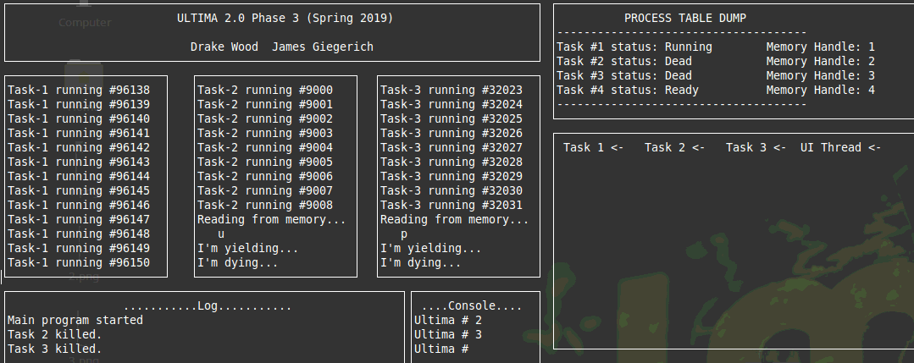

After the tasks are killed garbage collect is called which removes the dead threads from the process table. You can see that they are no longer included and only 3 and 4 remain (1 and 2 were killed this time) as well as the queue printout in the window below that.

Garbage collect
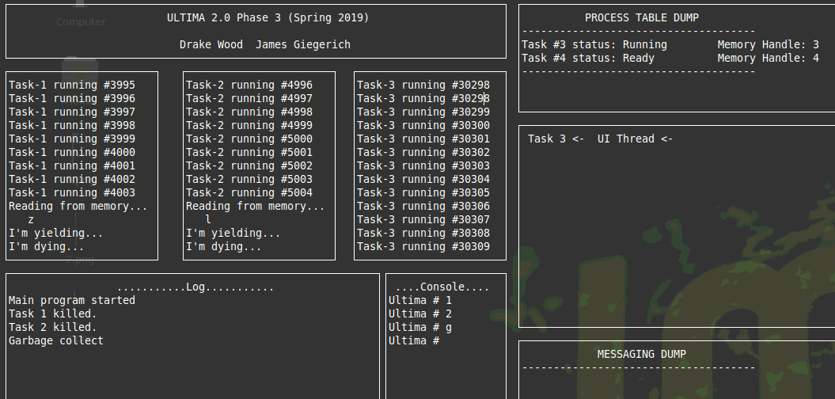

Calling r activates a semaphore that never does any up, calling it twice from the UI thread causes a deadlock where nothing can run. This doesn’t work as intended because we were not aware of an issue in the down function which does not allow the scheduler to continue past the current task if it were to become blocked like this situation.

Deadlock
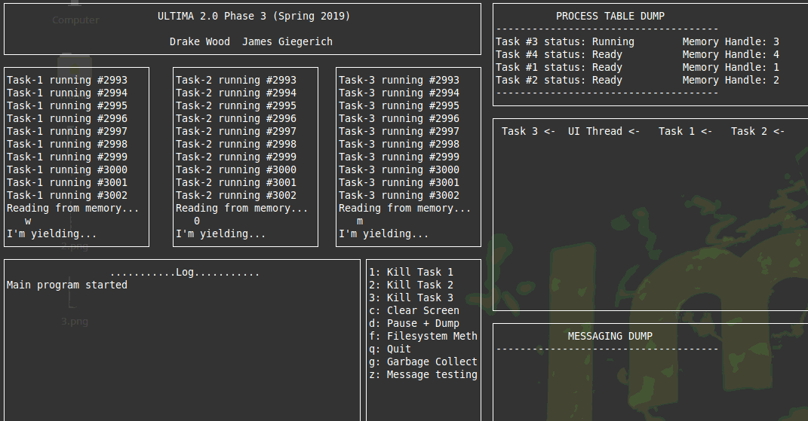

Phase 2:
This phase added message boxes for each task. Upon task creation each task sends messages to the other ones. Our test function prints the contents of the mailbox for task 1, and then displays how many messages there are in that box. Next it displays how many messages are in all boxes. After deleting everything that is in box 1 it displays the number of messages in box 1 and then all boxes again showing that they were deleted.
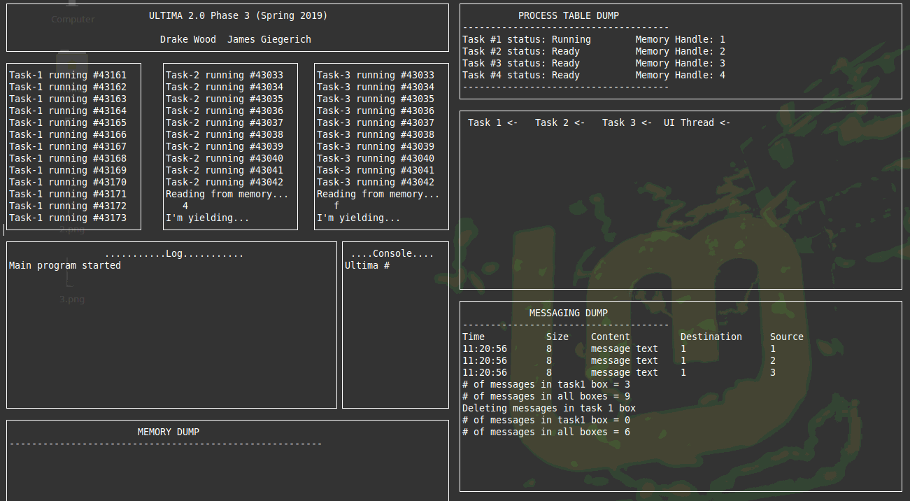

Phase 3:
Here we call a test function to demonstrate the memory management that was implemented in phase 3. First the core is dumped and the memory information for largest, smallest and left is displayed. After that the memory usage function displays the blocks which are used and free. Here we see that all 4 threads are using 1 block and there is 512/1024 space in a free block at the end.
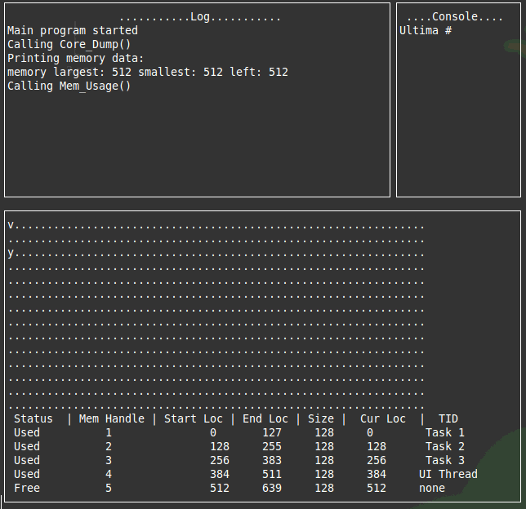

Next we call the overloaded memwrite function which adds a string to the middle of the memory core and then it is displayed with another core dump. We developed an issue with the output of the core at this point and it shows some corrupt characters at the beginning. This isn’t present in the actual memory and just effects the output.
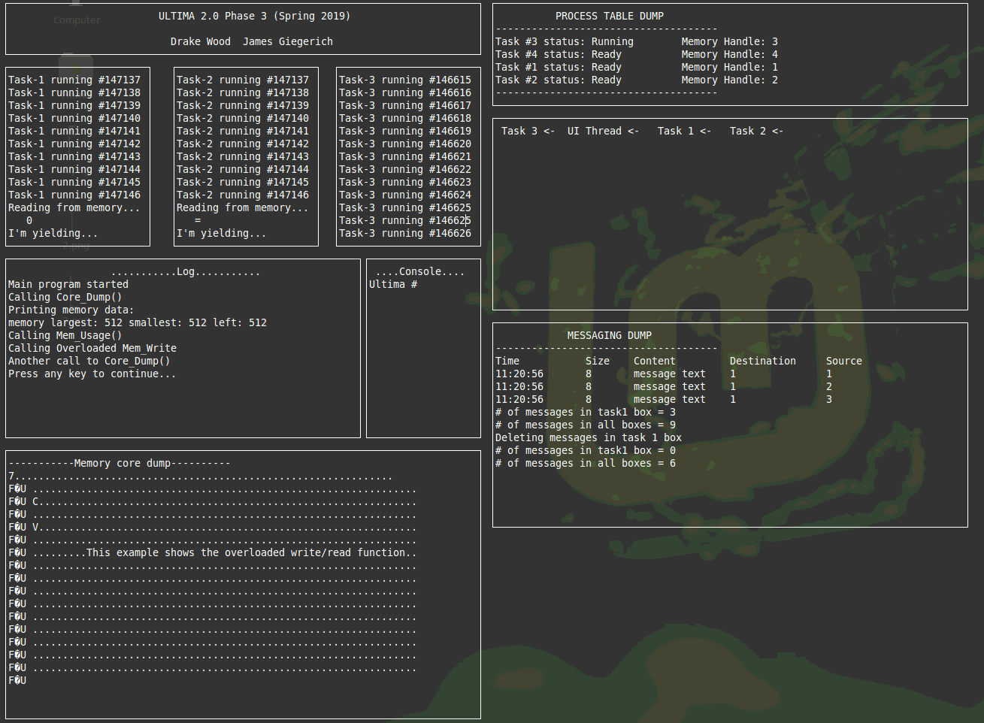

The next output is shown after tasks 1 and 2 have been killed, the memory for them has been freed but it has not been coalesced. Freeing the memory writes #’s to the contents.
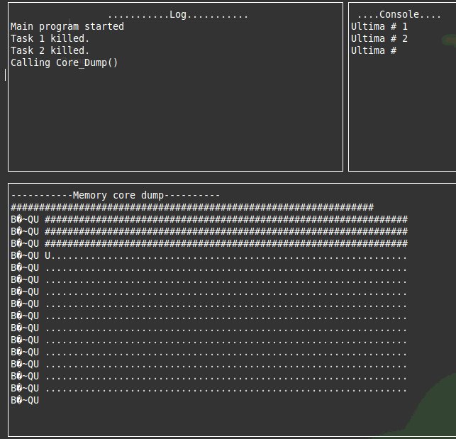

This output window calls the usage function to show that the free blocks are actually free but they are individual holes, not one larger free section of memory, the blocks for 3 and 4 are still intact.
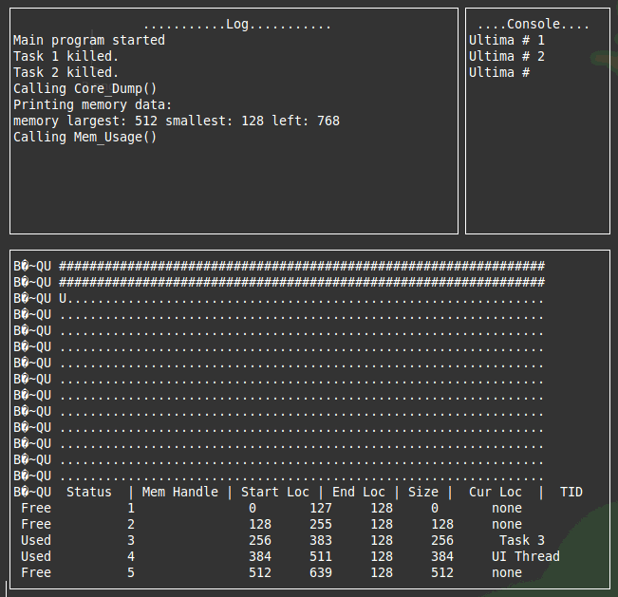

This core dump is after coalesce is gone and it shows that the freed memory is nor converted back to blank (…s).
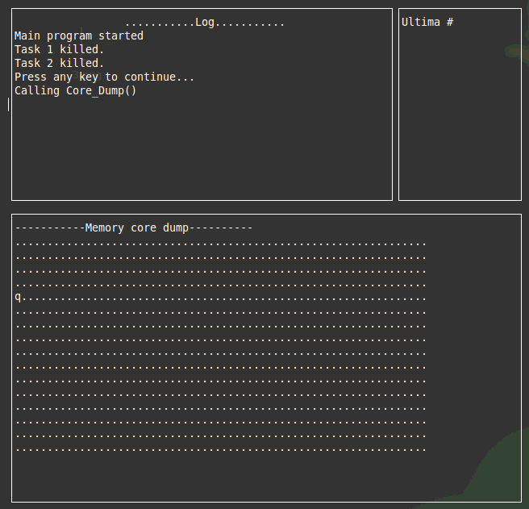

Phase 4:

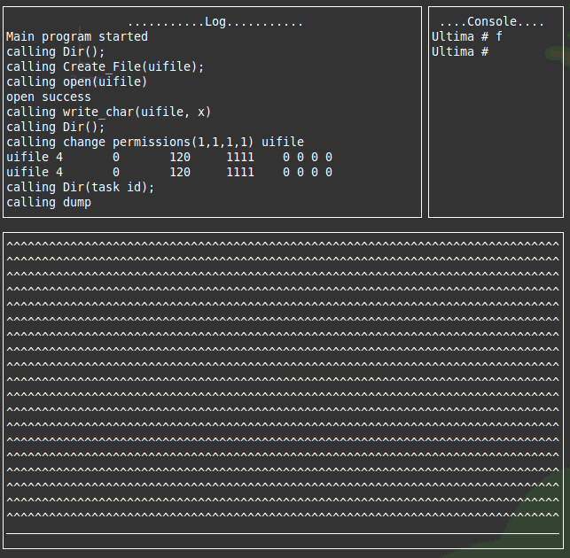

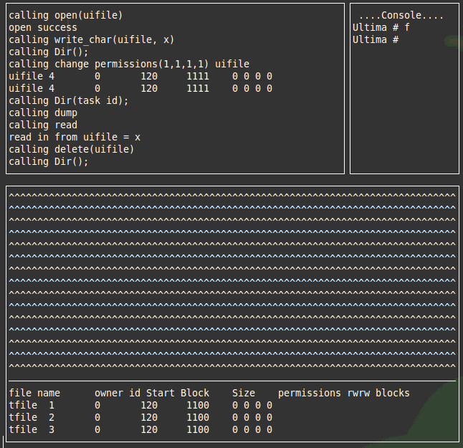

Overall Dump window
